Pi_grammer documentation example
PL 8/26/2016

Here are some example instructions and pictures that you may find useful when using the Pi_grammer in a test procedure.

X.) Grab the Pi_grammer (#XXX).

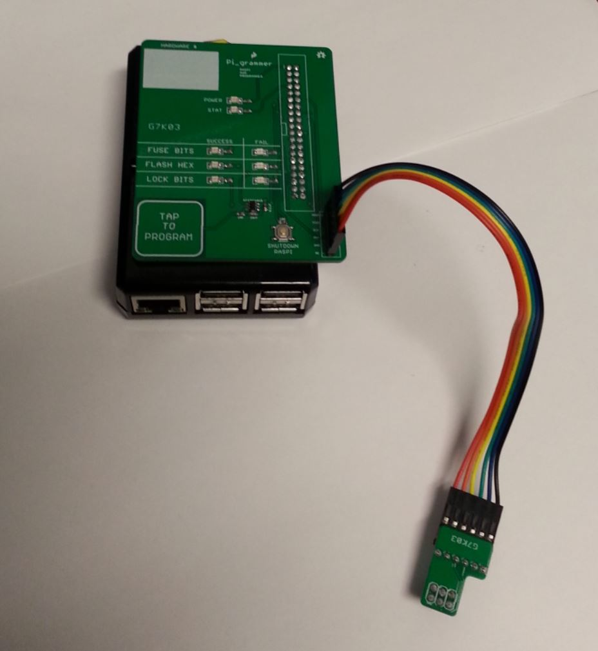

X.) Power Pi_grammer with a microB USB cable. Wait for bootup (90 sec). Verify STAT LED begins blinking.

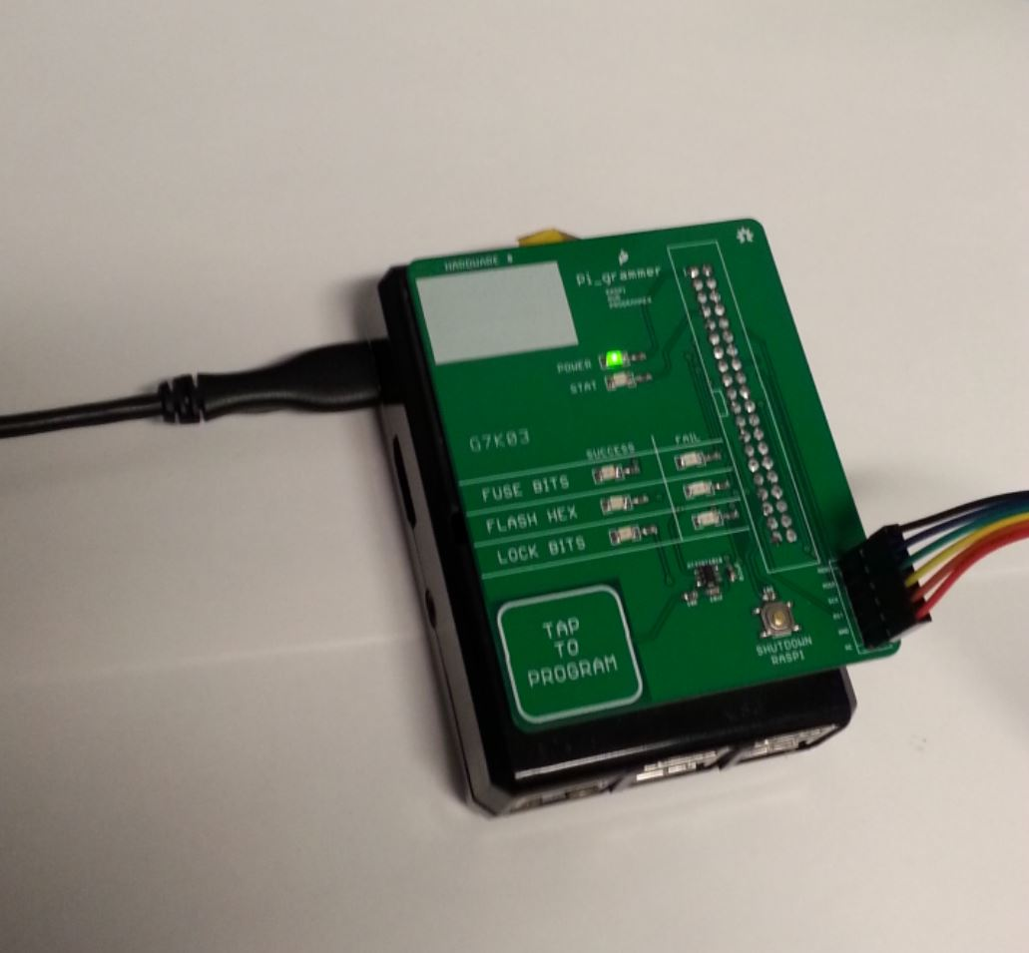 | 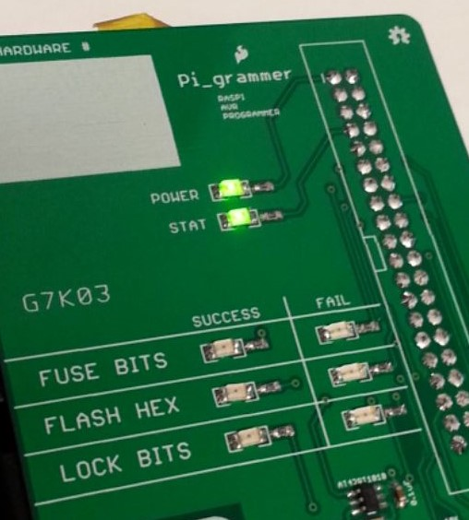

X.) Tap the capsense pad on the Pi_grammer to begin programming. Verify all 3 success LEDs come on.

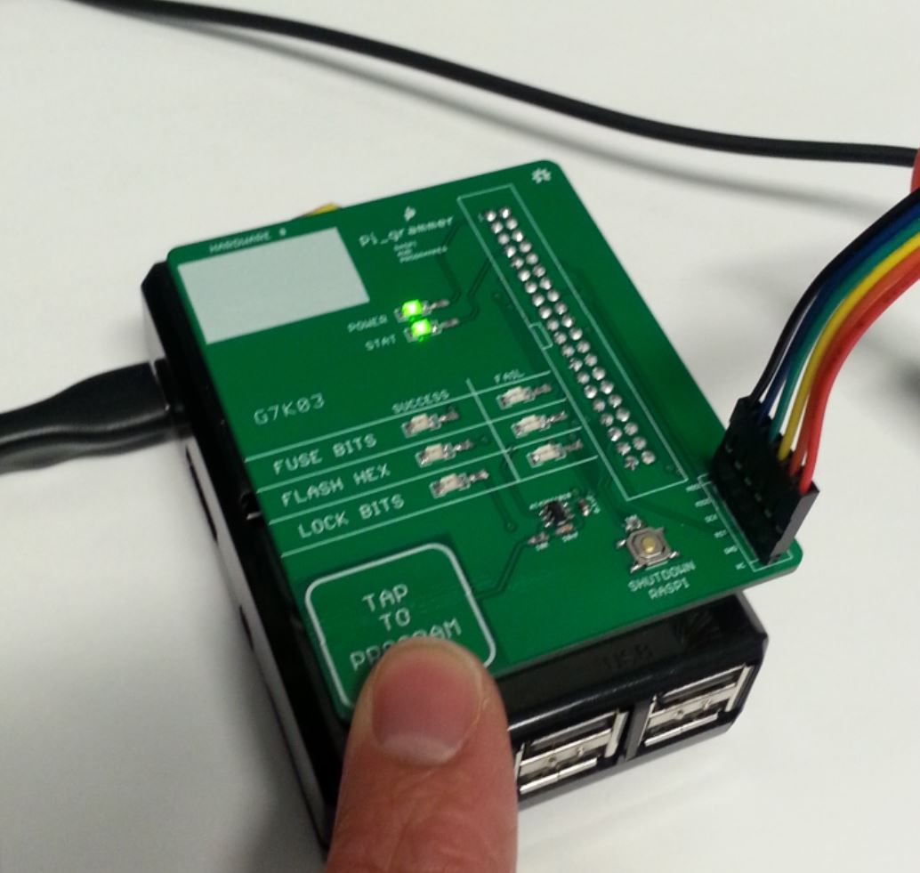 | 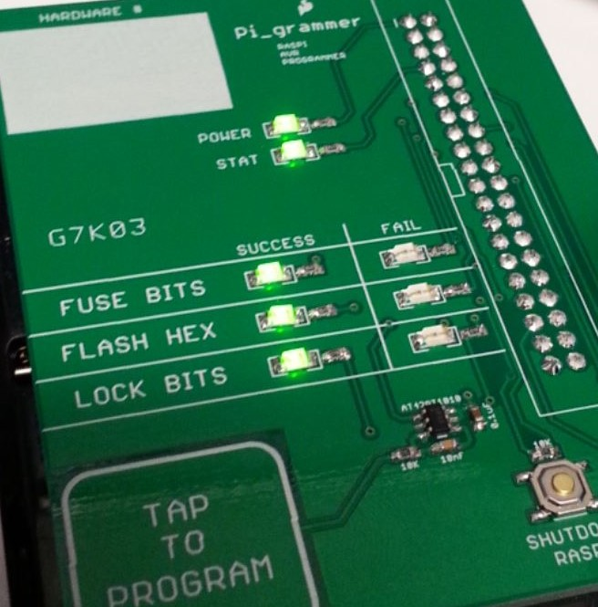

Note, all of the LEDs on the programmer will blink once to indicate that the button tap worked. The STAT LED will come on solid during programming.

Also note, watch carefully. The STAT LEDs only stay lit for 3 seconds to indicate success, and then turn off.

